 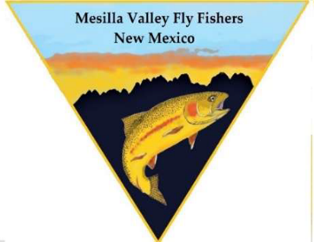

August 29, 2025

Representative Mathew McQueen

Commissioner Michael Perry

Mr. Jonas Moya

Mr. Juan Sanchez

Gentlemen:

Thank you very much for your commitment to attending the New Mexico Commissioner of Public Lands candidate forum in Las Cruces on November 19, 2025. Your forum hosts are the Dona Ana County Associated Sportsmen, New Mexico Trout Unlimited, the Mesilla Valley Flyfishers, the Friends of the Organ Mountain Desert Peaks, and the Mesilla Valley Audubon Society.

The location of the forum will be at Centennial High School, 1950 Sonoma Ranch Blvd, in the theatre building. Doors will open at 5:30 p.m., the question-and-answer session will promptly begin at 6:00 p.m. and end at 8:30 p.m. Our plan is to advertise this event in various newspapers, host organization newsletters and emails, and through various social media platforms. We will also send notice of this event to state and local political party organizations and ask that you post this event on your campaign website.

Let me tell you a little about how we will conduct the forum to ensure that each candidate is treated fairly. The format will be a timed question and answer session with a moderator asking the questions and a person monitoring time limits. Answers will be limited to 2 minutes. All candidates will be asked the same questions. Every candidate will begin by giving a 1-minute opening statement focused on introducing your background and experience. There will be a 1-minute open-ended closing statement for each candidate. At the end of the forum there will be 20 to 30 minutes of time for candidates to mingle with the attendees and share any other bits of information you would like to pass on.

The last time there was an open seat for the New Mexico Commissioner of Public Lands was in 2018. Many of us who are members of the host organizations helped conduct the previous Las Cruces New Mexico Commissioner of Public Lands forum with the entire slate of candidates attending as well as over 150 members of the public. Our goals for this forum are to ensure that the public knows about this event, that the public understand they are welcome at the event, and that there is a great turnout. We want attendees to learn about the mission, obligations and duties of the New Mexico State Land Office and any other focus you as the candidate will have if you are elected New Mexico Commissioner of Public Lands.

Your hosts are a mix of retired state and federal employees, lifelong sportsmen and women, and wildlife conservationists who have a considerable understanding of what this office entails. We are excited to host you, and we look forward to meeting you in November.

Respectfully,

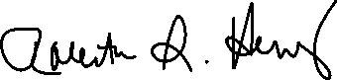

Roberta Salazar-Henry, Board Member

Dona Ana County Associated Sportsmen

Cc: John Cornell, DACAS

Jennifer Montoya, MVA

Jeff Arterburn, NMTU

Patrick Nolan, FOTOMDP

Bob Silver, MVFF